Sizes | Panther Logo  Quantity  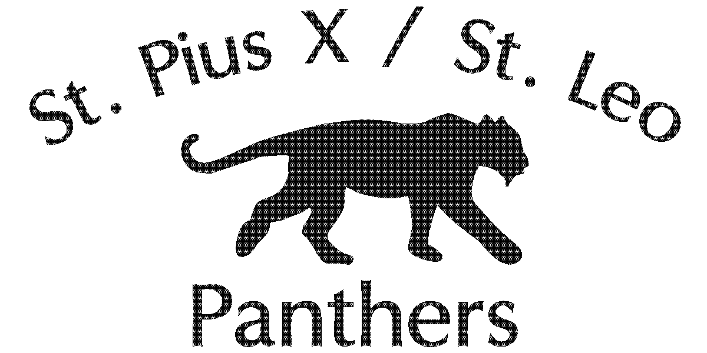 | School Logo  Quantity | Price Per Item | Total
Youth 6-8 |  |  | $12.50
Youth 10-12 |  |  | $12.50
Youth 14-16 |  |  | $12.50
Adult Small |  |  | $14.00
Adult Medium |  |  | $14.00
Adult Large |  |  | $14.00
Adult X-Large |  |  | $14.00
Adult XX-Large |  |  | $15.00
Adult XXX-Large |  |  | $15.00
 |  |  | Grand Total | $__________
ST. PIUS X/ST. LEO SCHOOL
UNIFORM SWEATSHIRT ORDER FORM

Student Name_________________________ Homeroom#____

Uniform sweatshirts are optional; each sweatshirt comes in your choice of a Panther or School Logo.
Please return completed order form along with cash or check payment to the school office. Your order will be processed and items delivered to your child’s homeroom.
All questions and/or special requests to Jeanette Weber @ Jweber@investorsomaha.com or 402 556 6809

