Robotics Club Parent Meeting
Feb. 7, 2022

The St. Pius X / St. Leo School Robotics Club will be utilizing the Vex IQ Challenge materials this year. The 2021-22 VEX IQ Game is Pitching In. Students in grades 3rd-8th are invited to participate.
Students will be put into teams based on grade level and will work together to design and build robots that can solve problems and play games.
Recommended team size is 3-5 student.

Robotics Club will meet on Mondays from 3:30-5:00 p.m. Meetings are held in the SPSL Parish Center.

** A completed Registration Form and the registration fee must be turned in BEFORE a child will be placed on a team.
Checks should be made to St. Pius X/St. Leo School. Please note Robotics Club in the memo line.
Registration forms can be found on the SPSL Website.
Completed Registration forms and payment can be sent to the school office via your student.
Registration Due Date: Thursday, February 10, 2022.

Season Dates:
February 21, 2022, thru April 11, 2020
VEX IQ teams will NOT be participating in League play or tournaments this year.
- 2/21 - First VEX IQ Meeting - Team Introductions
- 2/28 – Meeting
- 3/7 - No Meeting - No School (Spring Break)
- 3/14 – Meeting
- 3/21 – Meeting
- 3/28 – Meeting
- 4/4 – Meeting
- 4/11 – Final Meeting – Parent Presentations

Fees:
$30 per student
Includes:
*Use of VEX IQ base kits
*Use of 2021/22 season VEX IQ game pieces Pitching In
(All robotic pieces are the property of SPSL and must be returned at the end of the season.)
*Team Engineering Notebooks
*Club Fees

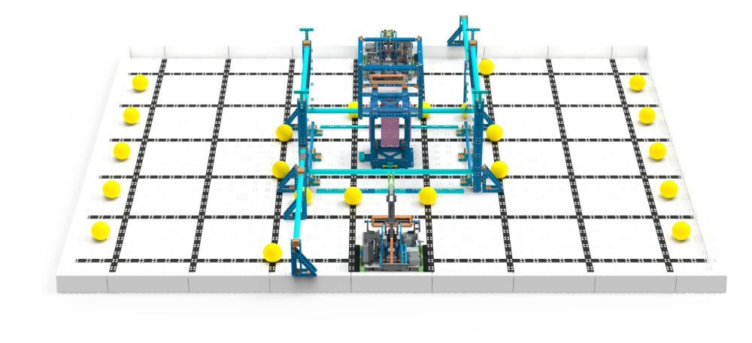

The Game:
VEX IQ Challenge Pitching In is played on a 6’ x 8’ rectangular field configured as seen above. Two robots compete in the Teamwork Challenge as an alliance in 60 second long teamwork matches, working collaboratively to score points.
Teams also compete in the Robot Skills Challenge where one robot takes the field to score as many points as possible. These matches consist of Driving Skills Matches, which will be entirely driver controlled, and Programming Skills Matches, which will be autonomous with limited human interaction.

The Details:
The scoring objects in VEX IQ Challenge Pitching In are 3” (7.62 cm) diameter Balls. There are a total of (22) Balls on the field. The object of the game is to score as many points as possible with your alliance partner by scoring Balls in Goals, clearing Corrals and Hanging at the end of the Match.

Scoring:

Each Ball Scored inside the Low Goal | 2 Points
Each Ball Scored inside the High Goal | 6 Points
Each Cleared Corral | 5 Points
Each Low Hanging Robot | 6 Points
Each High Hanging Robot | 10 Points

Parent responsibilities:
1) Volunteer. We cannot run the Robotics Club without volunteer coaches. We would like to have 2 coaches per team so that if one coach is busy on any given Monday, the second coach can supervise the team.
2) Help during Monday meetings. We need to make sure that the parish center is left the way we found it. Students may not leave meetings until all Robotics equipment is cleaned up, chairs are placed back around the tables, and any trash has been picked up. It is NOT the coach’s responsibility to clean up after your students. Please take a moment to come into the parish center at the end of each meeting to help us get things cleaned up. If you come in a few minutes early you will also get to see what the kids are working on!
3) Pickup. We will dismiss students out the parish doors on the north side of the building. (West, teacher’s parking lot.) Please be sure to pick up your student(s) precisely at 5:00 pm.
4) Please communicate with your student’s coach of any schedule conflicts you may have and if your child is going to miss a meeting. Coaches will also communicate with their teams individually if they will not be meeting during a regular Monday time.

Coaching:
Each team needs 1 to 2 coaches. Coaches can alternate weeks.
Coaches attend Monday meetings to oversee students.
No technical experience is needed.
**Coaches should NOT be building or documenting for students. All work is completed by the students. **
VEX IQ Coaches direct students to GROW - Goal. Reality. Options. Will.
All coaches must have Safe Environment Training. https://archomaha.org/safe-environment/

VEX IQ Tournaments:
We will not be attending any tournaments this season.

Club Expectations:
Students must be in the parish center by 3:35 PM to participate in Robotics Club.

Students will remain engaged in work with their group. When using devices, the sites/apps accessed should be limited to what has been designated by the robotics’ coach.

Students should not leave their group or the parish center without adult permission to do so; to use the restroom, get a drink, or when they go home for the evening.

Student behaviors will follow the expectations set during the school day following the R.O.A.R. model (Ready to Learn, Offer Respect, Achieve a Safe Environment, Respect Others and Ourselves).

Clean up: Students will help to put away their kits/robots, and game equipment after each meeting. Tables and chairs should be put back in place if they were moved during the meeting. Thank you for ensuring that the space is cared for and ready for the next day.

Robotics Club ends at 5:00. Students must be picked up from the west parking lot near the parish doors no later than 5:05 pm

Attire:
Students can wear their uniforms or appropriate street attire to practices.

Questions or Issues:
Once meetings have started, we ask that you communicate directly with your team coach regarding scheduling issues, missed meetings, etc. If you have additional questions or concerns, please let us know at karaepatch@gmail.com.

Thank you for your participation! We are looking forward to a great season!

Kara and Ryan Patch

