SPSL COMMISSION
BY LOCAL ARTIST, KATHI GERINGER

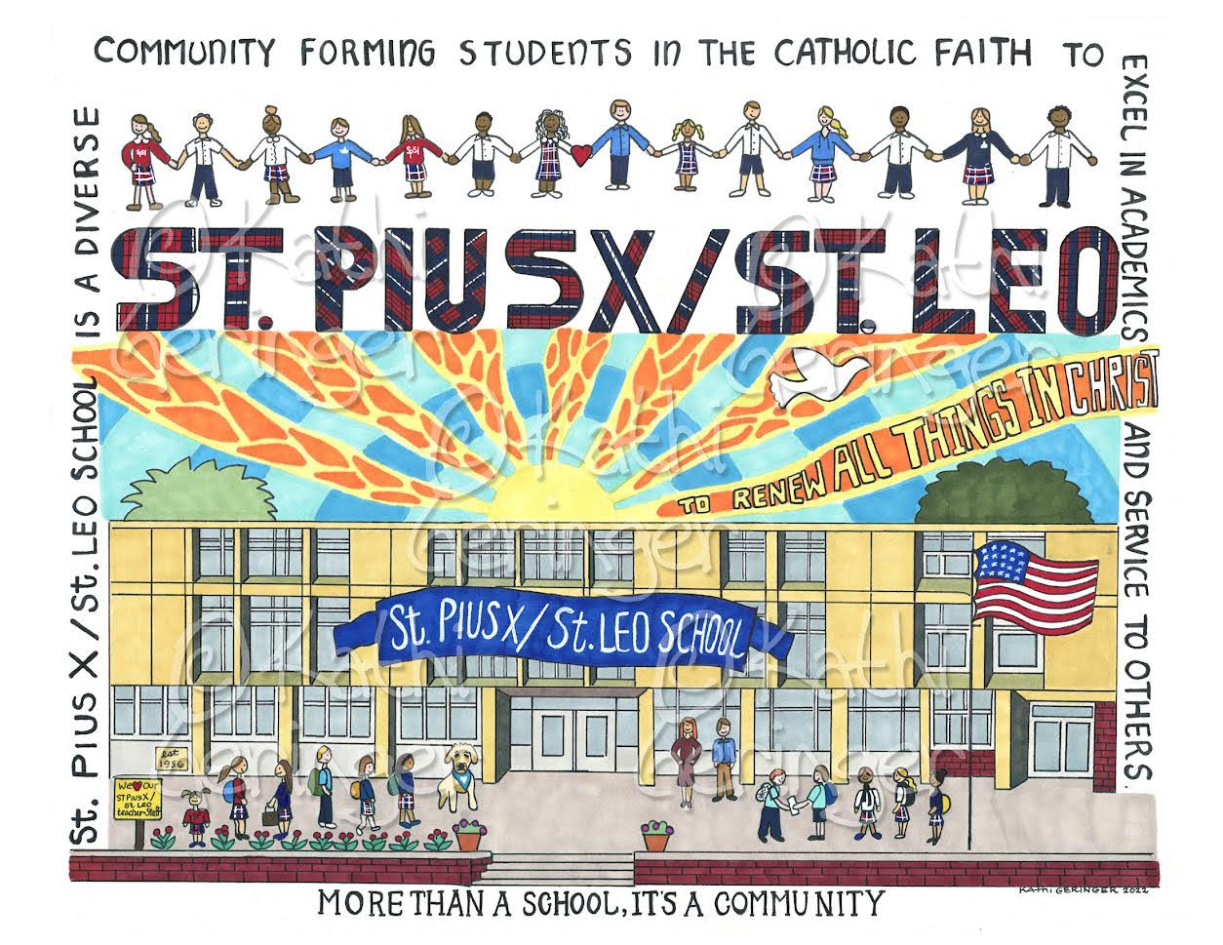

We are excited to share that Omaha artist Kathi Geringer has created a Commission for St. Pius X / St. Leo School, and prints are now for sale! Kathi Geringer is well known for the rich detail in her work celebrating Omaha homes, schools, churches and landmarks.

Kathi Geringer is donating the profits from sales of this commission to SPSL, so all purchases will help our school!

Please complete this form and return it to the SPSL School Office by Monday, April 22 with your payment (cash or check made payable to SPSL School). If you would like your order to be sent home with a student, please identify the student name and homeroom. We anticipate orders will be filled approximately two weeks from the date of ordering.

Name: ____________________________ Email: _____________________________

Student Name: ___________________________ Homeroom: ___________

Print Size | Price Per Print | Number Ordered | Total
8.5 x 11 | $15.00
13 x 9 | $20.00

TOTAL PAID: _____________

Questions? Contact Jessica Fisher at Jess.Fisher@spsl.net

