SPSL UNIFORM SWEATSHIRT ORDER FORM

Student Name_________________________ Homeroom#____
Sizes | Panther Logo  Quantity  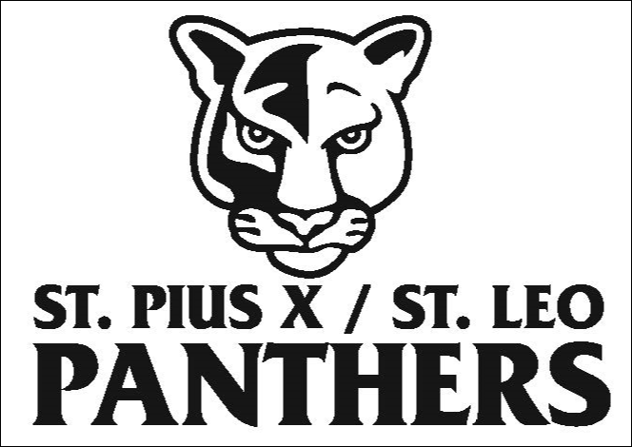 | School Logo  Quantity  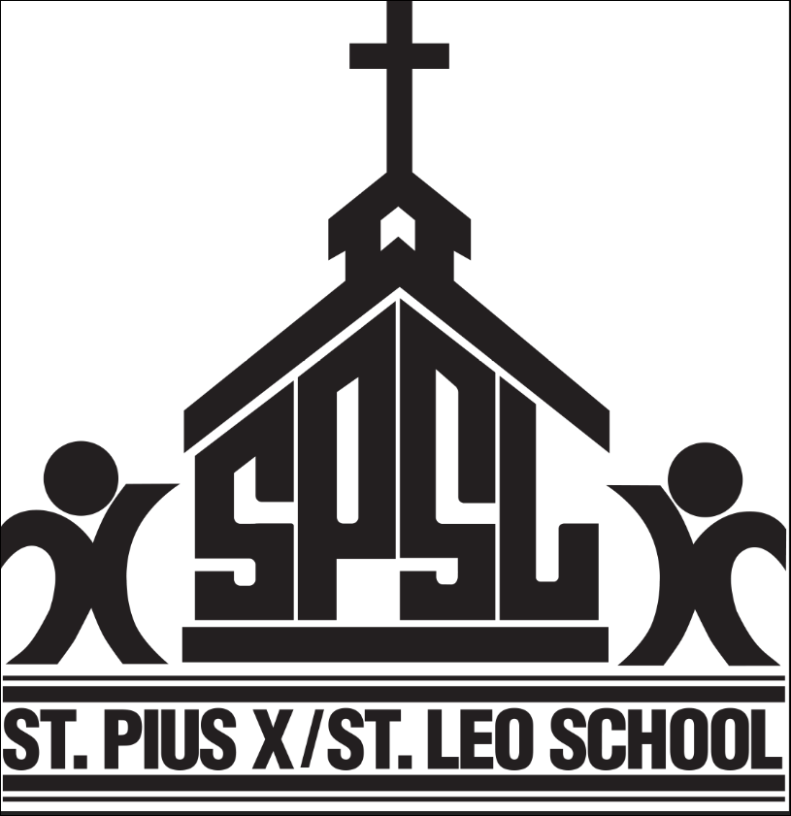 | Price Per Item | Total
Youth Small  Crew Neck |  |  | $15.00
Youth Medium  Crew Neck |  |  | $15.00
Youth Large  Crew Neck |  |  | $15.00
Adult Small  Crew Neck |  |  | $15.00
Adult Medium  Crew Neck |  |  | $15.00
Adult Large  Crew Neck |  |  | $15.00
Adult XL  Crew Neck |  |  | $15.00
Adult XXL  Crew Neck |  |  | $15.00
Youth Small  ¼ Zip | N/A |  | $25
Youth Medium  ¼ Zip | N/A |  | $25
Youth Large  ¼ Zip | N/A |  | $25
Adult Small  ¼ Zip | N/A |  | $25
Adult Medium  ¼ Zip | N/A |  | $25
Adult Large  ¼ Zip | N/A |  | $25
Adult XL  ¼ Zip | N/A |  | $25
Adult XXL  ¼ Zip | N/A |  | $25
 |  |  |  | TOTAL:

Panther logo is not available for ¼ zip sweatshirts. Please return completed order form along with cash or check payment to the school office. Your order will be processed and items delivered to your child’s homeroom.
Questions and/or additional size requests to Liz Burke @ eab42248@yahoo.com or text 952-239-9594.

